HARDWARE
MPU & FSR 3D MODEL
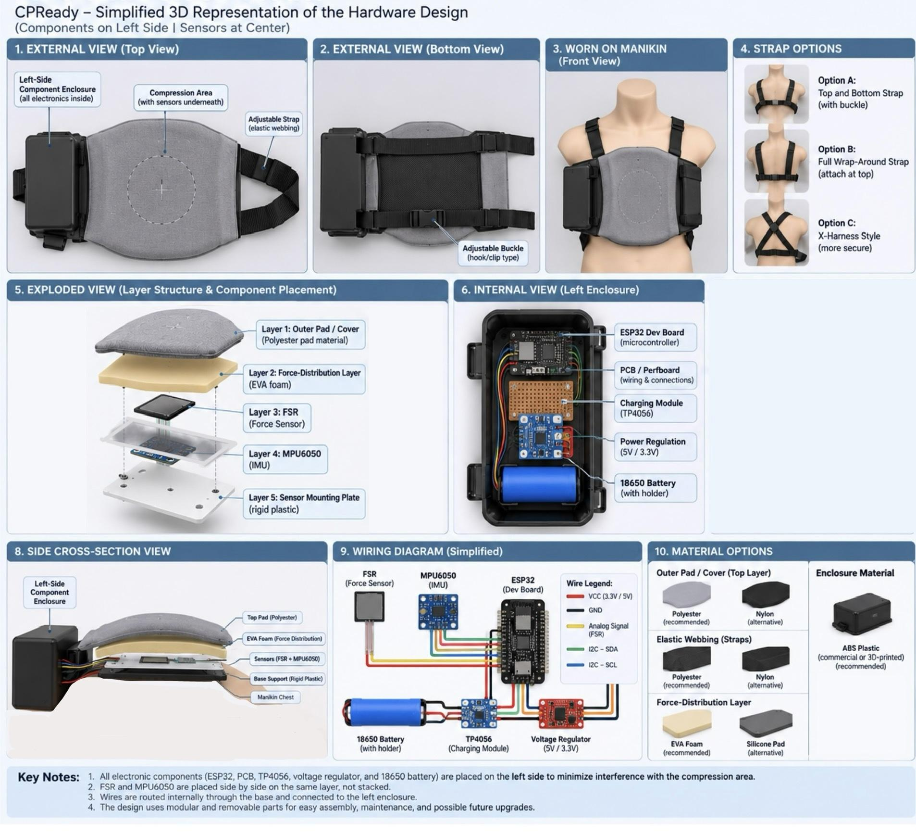

FOR CLEAR IMAGE: MPU & FSR 3D MODEL

Part | Current material direction | Status
Outer compression pad/cover | Pad material rather than ordinary fabric | 🟢 Direction agreed; polyester pad material
Force-distribution layer | Soft/compliant layer or suitable plate | 🟢 Direction agreed; EVA foam material
Harness/straps | Elastic webbing; polyester or nylon candidate | 🟢Direction agreed; polyester
Electronics/Components enclosure | Hard protective case | 🟢 Strong recommendation
Internal wiring | 22–26 AWG silicone-insulated hook-up wire | 🟢 Existing hardware direction; based on baseline
Prototype board | Solderless breadboard initially → solderable and customizable perfboard/PCB later | 🟢 Existing direction; for consultation with expert (customization of PCB)

The existing hardware research already specifies 22–26 AWG silicone-insulated hook-up wire and solderable perfboard/PCB for the final prototype.

Force-Distribution Layer
Its purpose is to make sure the force from the user’s hands is transferred to the FSR in a repeatable manner.
The FSR affects the sensor response in terms of:
- contact area,
- actuator shape,
- actuator material,
- compression surface,
- mounting method,
- sensor position, and
- force distribution
HAND
↓
[ TOP PAD ]
↓
[ FORCE-DISTRIBUTION ]
↓
[FSR]
↓
[MPU6050]
↓
[BASE SUPPORT]
↓
MANIKIN.
Question for expert:
What material or structure should we use between the compression pad and FSR to distribute the CPR force consistently without reducing the sensitivity of the FSR? [Are the current options of material feasible?]

Harness Material — Polyester vs Nylon

OPTION A — Polyester
Advantages:
- better heat resistance;
- better UV resistance;
- repels water;
- suitable where exposure to moisture/environmental conditions is a concern.

OPTION B — Nylon
Advantages:
- better physical strength;
- better abrasion resistance;
- more durable against physical wear.
Limitations:
- absorbs more heat;
- absorbs more moisture.

POLYESTER ELASTIC WEBBING
Our biggest requirements are:
- repeated use;
- adequate tensile strength;
- flexibility;
- resistance to moisture/sweat;
- reasonable heat resistance;
- stable dimensions;
- comfortable handling;
- compatibility with the pad;
- ability to repeatedly secure and release the device.
However, because Sir Rodel’s main requirement is security + flexibility, we shouldn’t finalize polyester solely from the material table.

Therefore:
Current candidate: Polyester elastic webbing
Alternative: Nylon elastic webbing
Final decision: After physical testing / expert’s recommendation.

Hook / Buckle / Connector Material
Elastic webbing
↓
Adjustment buckle
↓
Hook / connector
↓
Other side of harness
The connector needs to:
- withstand repeated attachment;
- maintain tension;
- not unexpectedly release;
- not damage the mannequin;
- not interfere with the electronics;
- be easy for students/instructors to operate.

Current decision
Hook/connector = YES
Exact type/material = OPEN

Electronics Enclosure — HARD CASE

These cases should be on the sides, specifically on the left side. Not underneath the central compression area.
That keeps:
CENTER → sensing
SIDES → electronics (e.g. ESP32, Battery, PCB…)
determine whether the practical fabrication method is:
- commercially available plastic enclosure;
- 3D-printed enclosure;
- acrylic;
- another rigid polymer;
- or another suitable material.

So:
Hard protective case = agreed direction
Exact material = Consult w/ expert / POSSIBLY 3D-Printed

Internal Wiring Material
For the final prototype:
22–26 AWG silicone-insulated hook-up wire and solderable perfboard/PCB while jumper wires and an 830-point solderless breadboard are intended for initial prototyping.
So:

During development
Jumper wires + solderless breadboard
↓

After circuit is validated
22–26 AWG silicone-insulated wire + solderable perfboard/PCB

1. Base / Structural Support
TOP
──────────────
Compression pad
──────────────
Force distribution layer
──────────────
FSR
──────────────
Rigid support
──────────────
MPU6050/support
──────────────
Rigid base/support
──────────────
Manikin
BOTTOM
The base should provide:
- structural support;
- sensor protection;
- stable mounting;
- controlled force transmission;
- compatibility with the strap system.
EXACT MATERIAL = NOT FINAL, BUT POSSIBLY POLYESTER (in consideration of advantages)
LAYERS

Layer 1 — Outer Pad
Purpose: provide the physical compression surface and protect the sensing assembly.
Current direction: pad material.

Layer 2 — Force Distribution
Purpose: distribute the compression force consistently toward the FSR.
Current direction: suitable compliant or structural force-transfer layer.

Layer 3 — FSR
Purpose: detect force-related changes from compression.

Layer 4 — MPU6050
Purpose: detect movement and timing information associated with compression cycles.

Layer 5 — Structural Base
Purpose: hold the sensing assembly and provide mechanical stability.

Side Enclosures
Purpose: isolate and protect the electronics from repeated compression.
Direction: rigid/hard protective case.

Harness
Purpose: keep the entire assembly securely positioned on the mannequin.
Direction: elastic webbing + hook/connector.
Current material candidate: polyester.
Alternative: nylon.
FINAL QUESTIONS:
# | Question
1 | For the updated list of components that we plan on using now, do you think it aligns with the functions that we will be needing in our device?
2 | After knowing the list of components we plan to use, will we encounter any technical problems with them working together, such as wiring, coding, simultaneous operation, overheating, soldering, delayed detection, or other compatibility issues?
3 | For our proposed sensor setup, is it better to use the MPU6050 and FSR together, or would using only one sensor be sufficient for measuring the CPR indicators we need? If both are used, is our proposed division of functions between the sensors practical?
4 | Since the FSR measures force rather than directly measuring distance, can we reliably use its calibrated force readings to determine compression depth, or would you recommend another method for obtaining depth in centimeters?
5 | For the FSR circuit, will we need a fixed resistor or other additional components? If so, what resistance value and circuit configuration would you recommend for our specific FSR and ESP32?
6 | Which FSR model and sensing-area dimension would be most suitable for CPReady (e.g., FSR 406, X 406, or UX 406; square or another form), considering our expected compression forces, required sensitivity, and available space?
7 | Since the sensors will be placed between the pad and the compression area, what type and thickness of pad, foam/buffer, or force-distribution layer would you recommend to protect the sensors while still allowing the compression force to be measured consistently?
8 | Do you think our sensors and other internal components could be damaged, displaced, or affected by repeated CPR compressions? What mounting or protective structure would you recommend to make the device durable and secure?
9 | For the physical attachment of the device to the mannequin, what strap or fastening configuration would you recommend to keep the sensor area properly aligned and prevent the device from moving during repeated compressions?
10 | For the ESP32, sensors, and other components, what battery type, voltage, capacity, and protection/charging circuit would you recommend so that the device can operate continuously for at least one hour without causing power or overheating problems?
11 | For the final prototype, what wiring method and wire specifications would you recommend? Which components should be soldered directly, and should we transition from the breadboard to a perfboard or PCB?
12 | Are there any components, features, or parts of our current design that you think are unnecessary or overly complicated and could be removed or simplified without affecting CPReady’s essential functions?
13 | For real-time CPR monitoring, what should be processed by the ESP32 before transmission to the application, and what information should actually be sent through Bluetooth to ensure that the feedback is responsive and accurate?
14 | When measuring compression depth, rate, recoil, and CCF, what programming or sensor-synchronization problems should we expect, and how can we prevent these from affecting the accuracy of the results?
15 | Considering our one-month development timeline, what part of the hardware and system should we prioritize first, and what features or functions would you recommend postponing until the core device is working reliably?
16 | Overall, after seeing our proposed hardware, physical structure, and system flow, do you think our current CPReady design is technically realistic? If not, what would you recommend changing before we begin fabrication and full development?

BASELINE INFO: https://www.mdpi.com/1424-8220/23/13/5948?fbclid=IwcGRvZgRleHRuA2FlbQIxMQBzcnRjBmFwcF9pZA80Mzc2MjYzMTY5NzM3ODgAAR6vhbTnrqex1aRq1y3iu--wN8JS3m5mOSvBaZhsndmmbQy0KDDHlMX1Uh_zPg_aem_Nvwbq5etvwnOrT2xDp42dQ

